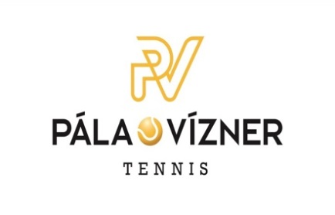
CAMPS 2024, PLAYER APPLICATION

Players personal data:
Name, Surname:
Date of Birth
Term: | 8-12.7. / 5-9.8. / 26- 30. 8. 24 (Delete where not applicable)

Parent's personal data:
Name, Surname
Phone:
E-mail:

Please send the amount of 1.200 CZK per day or CZK 6,000 for the entire camp to the club's account:
9292023001/5500 (note the name of the player)

DECLARATION BY THE CHILD'S LEGAL REPRESENTATIVES OF INFECTION-FREENESS
I declare that the attending physician did not order the child:

change of regimen, the child does not show signs of an acute illness (diarrhea, temperature, etc.) and the hygienist or attending physician has not ordered quarantine measures. I am also not aware that in the last two weeks this child has come into contact with persons who have contracted a communicable disease.

I am aware of the legal consequences that would befall me if this statement of mine were false.

Affidavit:

I declare that I am given permission to transport my child by car in the event of an accident or the need to visit a doctor within the tennis camp.

Parents are asked to complete the following:
Allergy:

Permanent use of drugs or other regular treatment methods:

I hereby confirm that I agree to the processing of personal data.

Protection of personal data The company hereby takes the liberty of briefly informing you about the processing of personal data. More detailed information related to the processing of personal data can be found in the Principles of processing personal data published at www.palaviznertennis.cz. The association, as the administrator of personal data, processes the personal data provided above, as well as other personal data such as photos or videos, on the basis of this application. The purpose of personal data processing is determined by your child's membership in the Association. The legal title for the processing of personal data is the fulfillment of contractual obligations based on this application and the Association's statutes, as well as the fulfillment of the Association's legal obligations and legitimate interests of the Association. The association processes personal data manually in paper form, as well as by automated means in electronic form. Recipients of personal data are mainly members of the association's body and coaches. Personal data are not transferred to third countries. The association undertakes that in case of processing or transfer of personal data, adequate steps will be taken to ensure data protection, so that your personal data is processed in accordance with applicable legislation. We process your personal data for as long as is absolutely necessary personal data; (iii) the right to correct and supplement your personal data; (iv) the right to erasure of your personal data; (v) the right to limited processing of your personal data; (vi) the right to object to the processing of your personal data; (vii) the right to transfer your personal data to another administrator; (viii) the right to information about the measures taken; (ix) the right to file a complaint against the processing of your personal data or the processing of your request to the Office for the Protection of Personal Data; (x) the right to withdraw consent to the processing of personal data; and (xi) the right to enforce your rights in court.
To exercise your above-mentioned rights or have any questions regarding the processing of personal data, please contact our Association by email at vizner@palaviznertennis.cz or phone number +420 739 220 222.

By sending or signing, I am binding to register my daughter/son for the camp, which takes place at the tennis club Pála Vízner Tennis at the address Suttnerová 841/2, Prague 6, and I declare that all the information given in the questionnaire is filled in correctly and truthfully and that I understand the conditions , which I posted on the website http://www.palaviznertennis.cz

------------------------- ----------------------------------
In Prague, date: Signature of legal representative:

